Florida Ambulance Association
Meeting Agenda | January 19, 2017 at 8:00 a.m. ET | Daytona Beach, FL

President’s Greeting & Welcome
- Review/approve minutes from the October membership meeting.
- Today’s meeting is on a very tight timeline.

Financial Report
- The December 31, 2016 month-end bank balance was $105,599.69, a year-over-year increase of $88,051.89.
- If you have not yet renewed, please contact faa@the-aaa.org for a copy of your invoice. Paper copies are also here in Daytona—see Amanda Riordan for assistance.

Florida Office of the Insurance Consumer Advocate’s Emergency Medical Transportation Working Group
- 20 responses were received to the recent FAA Ambulance Provider Survey.
- President Eismann and Joe Scialdone are developing a presentation for the working group’s February meeting using this data.
- Background details are available at http://bit.ly/FLemtworkinggroup.
REPLICA EMS Compact (Recognition of EMS Personnel Licensure Interstate CompAct)
- The board has asked Sue Prentiss, REPLICA Advocate, for a draft statement of support for FAA’s review.

“State of the Association” Project
- President Eismann announces the initiation of a new “State of the Association” project to highlight the value of membership to the Florida Ambulance Association.
- The report will debut at the next FAA membership meeting.

2017 FAA Education
- FAA will co-host an early-May AAA regional workshop at Sunstar Paramedics in Largo, FL. Details of this session, featuring Brian Werfel, Esq and Scott Moore, Esq, will become available in February.
- The FAA will again offer a one-day workshop in conjunction with ClinCon in July in Orlando. Content is in development, but will touch on PPOs, HMOs, and other critical Florida-specific issues. Thank you to Florida Hospital Center for hosting!

AHCA MMA Reimbursement
- David Rogers, FAA’s former contact at AHCA, has moved on.
- The FAA leadership team continues to work toward resolving these issues.
- Representative Mike Grant, an FAA advocate, has returned to office.

Government Affairs Committee
- The board plans to create a committee to spearhead FAA’s government affairs efforts.
- Topics to be discussed may include Prior Auth, Post Auth, MMAs, and other legislative and regulatory topics.

Recognition of Service
- Thank you to long term former board members Dave Dyal, John Glover, and Mark Postma, as well as Immediate Past President Alan Skavroneck.

First Coast Service Options (FCSO) Ambulance Presentation
This 90 minute portion of the FAA Membership Meeting has been approved for NAAC CEUs. Beginning Friday, January 20 NAAC-certified individuals can download a certificate of attendance from our member-only Meeting Documents page.
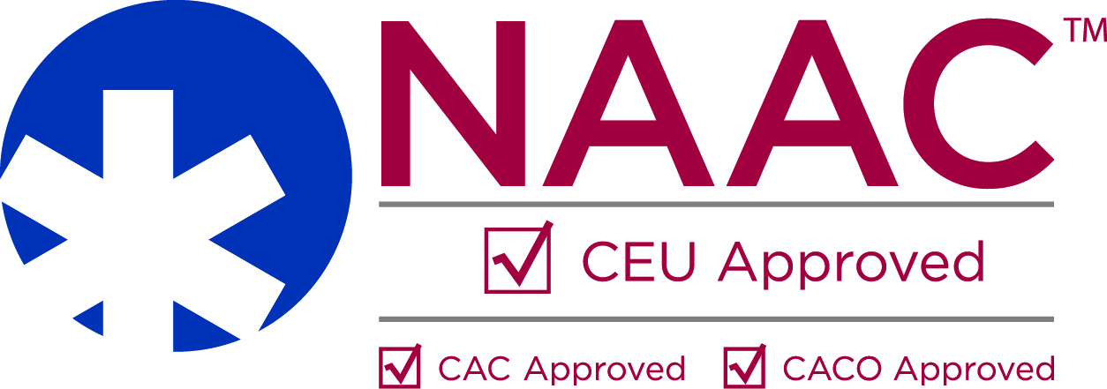
- Presenter Bio: Robert Lewis, FCSO
Robert Lewis has 25 years of experience in the healthcare industry in roles ranging from medical assistant in a primary care physician’s office to provider relations representative at First Coast Service Options. After graduating from the University of Virginia with a bachelor’s degree in biology, he began his career in the private sector at Florida Blue. He then joined First Coast’s Provider Outreach and Education in 2004, where he pursued his coding credentials to become a Certified Professional Coder (CPC).
- Presentation slides can be downloaded from the member-only Meeting Documents section of the FAA website.

Next Meeting
- The state has not confirmed the schedule for the next meeting.

Adjourn

